**CHAPTER 2**

**MATHEMATICAL MODELS OF GENERALIZED ELECTRIC MACHINES**

At present, one of the important tasks of the mathematical theory of electrical machines is the creation of the generalized mathematical model.There is different approaches of the solution of mathematical model. This problem is solved on the base of the field theory and circuit theory. Field theory is developed on the basis of Maxwell's equations, while the circuit theory is based on the Kirchhoff's equations. In spite of achievements in the creation of the models of electrical machines on the base of the equations of field, more successfully are simulated electrical machines with the aid of the equations, comprised on the basis of the circuit theory.

**2.1 Transformer type equivalent circuit of the induction motor**

The well known transformer type equivalent circuit model of the induction motor has been widely used over the years to examine the steady state behaviour of induction motor.

The equivalent circuit (EC) for an induction motor is shown in (Fig-2.1 a). It can give erroneous results when either the stator or rotor circuits have power electronic devices connected to them, if the machine itself has any phase unbalance or during severe transients created during starting or auto reclosing.

The transformer type EC, a variation of the equivalent circuit (Fig-2.1 b), can be used with fair accuracy for rectifier calculations, while including the effect of source impedance induced overlap. Parameters of the transformer type EC are related to those of the EC in the following way:

(fig 2.1 a)



(fig 2.1 b)

(Fig-2.1) The conventional (a) transformer type (b) equivalent circuits of the induction motor  (2.1)

 (2.2)

From (2.1 b), the motor equations for the steady state mode of operation with sinusoidal currents are as follows;

 (2.3)

 (2.4)

 (2.5)

Both the transformer type model and equivalent circuit of the induction motor neglect mutual inductance effects and therefore cannot be applied for an accurate prediction of the transients in the motor. Hence more rigorous models should be used for the analysis of the motor, particularly when driven by variable speed frequency controlled induction motor, when the machine has impedance unbalance or subjected to certain forms of supply unbalance.

**2.1 The Primitive Four-Winding Machine**

All electric machines are identical in the sense that they convert-energy from electrical to mechanical form or from mechanical to electrical form. But electric machines even of the same series differ from one another in performance. The basic types of electric machines can be reduced to a genera­lized, or primitive, model representing a set of two pairs of windings-moving with respect to each other. Steady state models of the induction machines are useful for studying the performance of the machine in steady state. This means that all electrical transients are neglected during load changes and stator frequency variations. Such variations arise in applications involving variable speed frequency controlled induction motor. The variable speed frequency controlled induction motors are converter fed from finite sources, unlike the utility sources, due to the limitation of the switch ratings and filter sizes. This results in their incapability to supply large transient power. Consequently, there is a needed to evaluate the dynamics of variable speed frequency controlled induction motor to assess the adequacy of the converter switch and the converter for a given motor and their interaction to determine the excursions of current and torque in the converter and motor. The dynamic model considers the instantaneous effects of varying voltages or currents, stator frequency, and torque disturbance.

. In (Fig-2.2) is shown the ideali­zed model of a symmetric machine having a smooth air-gap struc­ture and sinusoidal winding. A sinusoidal varying voltage applied to the winding produces-a circular field in the air gap. With the windings being symmetric, a sinusoidal symmetric voltage sets up a sinusoidal field in the gap.

The term 'primitive machine' stands for an idealized two-pole two-phase symmetric (balanced) machine having one pair of windings on the rotor and the other pair on the statoras shown in (Fig-2.2). Here  are the stator windings along the *α* and β axes; are the rotor windings along the α and β axes;

are voltages along the *α* and β axes on the stator and rotor respec­tively and  is the angular speed of the rotor.

The two-phase machine has four windings and is describable by four voltage equations (a minimum number of equations in comparison with those used for describing single-phase, three-phase, and m phase machines). An idealized electric machine has

1. Balanced rotor and stator windings, with sinusoidally distributed mmf.
2. The slotting effects are neglected.
3. The permeability of the iron parts is infinite.
4. The flux density is radial in the air gap.
5. Iron losses and saturation effect are neglected.
6. Inductance varies sinusoidally with rotor position.



Fig (2.1) A primitive machine

The idealized machine model is the analogy of an induction machine when the stator windings  and  accept sinusoidal voltages at frequency, f1 = 90° apart in time. The rotor windings carry currents of frequency f2 =f1 s*,* either produced by the voltage applied to the rotor or induced by the currents in the stator windings. In an induc­tion machine, the rotor angular speed is (is the synchro­nous speed of the field), and the rotor and stator fields are stationary with respect to each other since the mechanical rotor speed  plus/ minus the rotor field speed relative to is equal to .

The processes of electromechanical energy conversion in the pri­mitive machine are described by voltage equations (2.6) and equa­tion of motion (2.7).

Eq. (2.6) and (2.7) together with the equation for an electro­magnetic torque form thefundamental system of equations of elect­romechanical energy conversion.

In Eqs. (2.6),  are the voltages and currents in the stator and rotor windings on the α and β axes respectively;  are the resistances of stator and rotor windings respectively; M is mutual inductance; and are total inductances of the stator and rotor windings along the *α* and β axes respectively.

 (2.6)

 (2.7)

Winding inductances are defined by the known relations

  (2.8)

 

where  are leakage inductances of the stator and rotor windings along the α and β axes respectively.

The mutual inductance and leakage inductances are found by the known methods involving the calculations or experimental analy­sis, i.e. using equivalent circuits and design formulas. The assump­tion is that there is a working flux which links the stator and rotor windings and also leakage fluxes linking only one winding.

Equations (2.6) describe a hypothetical machine having the same number of turns on the stator and on the rotor, with the wind­ings being pseudo stationary. To preserve the power invariance in an actual machine and in the machine with stationary windings, the equations have to contain the EMFs of rotation, expressed as  for the rotor winding along the α axis and as for the β axis winding.

Kirchhoff's equations (2.6) include voltages, voltage drops across resistances, EMFs of rotation that exist only in rotating win­dings and transformer EMF

  (2.9)

The transformer EMFs for the β axis findings are written in a simi­lar form.

In the equation of motion (2.7), *p* stands for the number of pole pairs, and J for the moment of inertia. If the analysis is made of an electric machine together with its drive mechanism, the quantity J must represent the rotor moment of inertia and the normalized moment of inertia of the mechanism.

In the analysis of electric machines, the moment of resistance *Mr* (torque) is usually taken constant. In the analysis of electrome­chanical systems, *Mr* can be a function of or time.

The electromagnetic torque *Me* —the torque produced by a con­verter—is given by the products of currents flowing in the windings:

 (2.10)

where *m* is the number of phases.

**2.2 Real time model of a two-phase induction machine**

In a two-phase coordinate system, two pole electric machine (Fig-2.3), it has two orthogonal systems of stator and rotor windings, andrespectively, lying on the stator and rotor axes qs, ds,and α, β*.* The rectangular coordinate frames of the stator and rotor move with respect to each other, and the angle θr between the axes determines the relative rotational velocity.



Fig (2.2) the machine model arranged in a non-transformed coordinate system

With the stator being stationary,

 (2.11)

The terminal voltages of the stator and rotor windings can be expressed as the sum of the voltage drops in resistances and rates of change of flux linkages, which are products of current and inductances. These are as follows:

 (2.12)

Under the assumption of uniform air gap, the self-inductances are independent of angular positions; hence, they are constants:



The mutual inductances between the stator windings and between the rotor windings i.e. Lαβ, Lβα, Lqd, and Ldq are all zero since the windings are displaced in space by 90 degrees.

The mutual inductances between the stator and rotor windings are a function of rotor position, θr, and they are assumed to be sinusoidal functions because of the assumption of sinusoidal mmf distribution in the windings.

Symmetry in windings and construction causes the mutual inductances between one stator and one rotor winding to be the same whether they are viewed from the stator or the rotor:

 (1.3)

Lsr is the peak value of the mutual inductance between a stator and a rotor winding. Substituting (1.2) and (1.3) into (1.1) yields:

 (1.4)

Where,



**2.3 Transformations to obtain constant matrices**

This is achieved by replacing the actual with a fictitious rotor on the q and d axes as shown in Fig. 2.



Fig. 2: Transformation of actual to fictitious rotor variables

The fictitious rotor will have the same number of turns for each phase as the actual rotor phase windings and should produce the same mmf. Then the fictitious rotor currents iqrr and idrr are equal to the sum of the projections of iα and iβ on the q and d axis, respectively, as below:

 (1.5)

Applying the transformation of (1.5) to (1.4) to obtain the following:

 (1.6a)

Substitute Vα and Vβ in (1.4) with Vqrr and Vdrr, respectively and rearrange into matrix form to yield:

 (1.6b)

The rotor equations need to be referred to the stator in order to remove the physical isolation and facilitate the corresponding stator and rotor d and q axes windings becoming physically connected. This is achieved as follows:

 (1.7)

Note the following:

 (1.8a)

Consequently, the magnetising inductance of the stator is derived as follows:

 (1.8)

Substituting (1.7)-(1.8) into (1.6) yields the machine equations referred to the stator as follows:

 (1.9)

The impedance matrix has constant inductance terms and is no long2er dependent on the rotor position. Some of the impedance matrix elements are dependent on the rotor speed, and only when they are constant as in steady state, does the system of equations become linear. In the case of varying rotor speed and if its variation is dependent on the currents, then the system of equations becomes nonlinear.

**2.4 Phase Coordinate Model (ABC) of the induction machine**

In a three phase coordinate system, three poles electric machine in fig (3.1), it has three orthogonal system of stator and rotor voltages VA,VB, VC and Va,Vb,Vc respectively lying on the stator and rotor axes as,bs,cs and ar,br,cr. The rectangular coordinate frames of the stator and rotor move with respect to each other, and the angle θ between the axes determines the relative rotational velocity.

Let us examine the system of differential equations 3m in the untransformed phase axes. For this purpose let us examine the idealized model of electrical machine (3m) with magnetoconnected three-phases circuit fig (2.3). If it is examined by the induction motor with the cage rotor, then rotor voltages are



With the stator being stationary,

 (2.20)

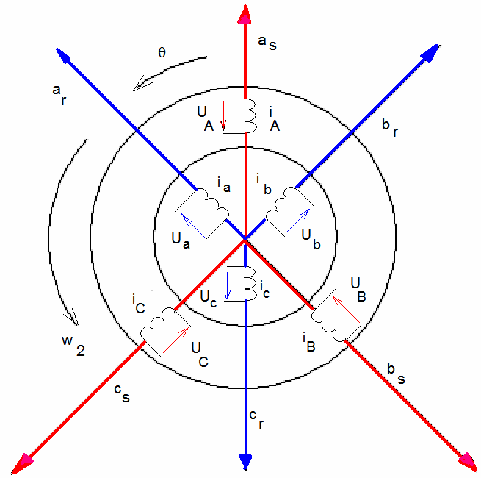

Fig (2.3) phase coordinate model of the generalized induction motor

The differential equations of voltages in natural or phase (non-transformed) coordinates have the form;

 (2.21)

 (2.22)

 (2.23)

 (2.24)

 (2.25)

 (2.26)

The instantaneous stator flux linkage values per phase can be expressed as;

 (2.27)  (2.28)  (2.29)

In a similar way, the rotor flux linkage values per phase can be expressed as;

 (2.30)

 (2.31)

 (2.32)

Where,

 





The mutual inductances between the stator and rotor windings are a function of rotor position, θ, and they are assumed to be sinusoidal functions because of the assumption of sinusoidal MMF distribution in the windings. Symmetry in windings and construction causes the mutual inductances between one stator and one rotor windings to be the same whether they are viewed from the stator and rotor.

Where, 

  

  

  

Substitute in equations (2.27 to 2.32);

 (2.33)

 (2.34)

 (2.35)

 (2.36)

 (2.37)

 (2.38)

Taking into account all the previous equations, and using the matrix notation in order to compact all the expressions, the following expression is obtained:



(2.39)

So it is possible to rewrite,

 (2.40)

Where,

  

  





The rotor equations need to be referred to the stator in order to remove the physical isolation. This is achieved as follows;

  

Consequently, the magnetising inductance of the stator is derived as follows:

    









  





it is possible to rewrite;

 (2.41)



(2.42)



(2.43)



(2.44)



(2.45) 

(2.46)



(2.47)



(2.48)

The differential equations of the flux linkage are as follows;



(2.49)

(2.50)



(2.51)



(2.52)



(2.53)



(2.54)

T he voltage equations of the non-transformed coordinate systems are as follows;



(2.55)



(2.56)



(2.57)



(2.58)



(2.59)



(2.60)

The expression for electromagnetic torque is as follows;



(2.61)

Where P is number of poles in the motor.

In the case of Y or ∆ stator connected squirrel cage induction motors,

 (2.62)

Thus, the ABC model allows the tracking of the “natural” phase current directly at any time of a transient. Also the model of the form is not limited by conditions of symmetry of either supply voltages or phase impedances. But, the inherent defect of the direct application of the ABC model for digital simulation of the motor transient is the large computation time required for inversion of the time varying inductance matrix in equation (2.24) during each step of integration.

**2.5 Space Phasor Notation**

Space phasor notation allows the transformation of the natural instantaneous values of a three-phase system onto a complex plane located in the cross section of the motor. In this plane, the space phasor rotate with an angular speed equal to the angular frequency of the three phase supply system. A space phasor rotating with the same angular speed, for example, can describe the rotating magnetic field. Moreover, in the special case of the steady state, where the supply voltage is sinusoidal and symmetric, and the space phasor become equal to three-phase voltage phasors, allowing the analysis in terms of complex algebra. It is shown in figure (2.4) the equivalent schematic for this model.

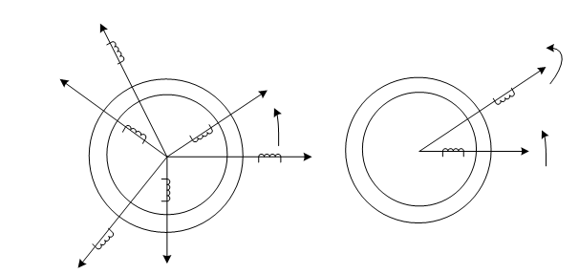

Figure (2.4) on the right the equivalent two rotating windings induction motor

In order to transform the induction motor model, in natural co-ordinates, into its equivalent space phasor form, the 120º operator is introduced:

  (2.63)



Fig (2.5) the vectors of the currents of three phases

**2.5.1 Current space phasor**

The stator current space phasor can be expressed as follows;

 (2.64)

 (2.65)

The relationship between the space phasor current and the real stator phase currents can be expressed as follows;

(2.66)

 (2.67)

 (2.68)

In a similar way, the space phasor of the rotor current can be written as follows:



(2.69)

 (2.70)

 (2.71)

**2.5.2 Flux Linkage space phasor**

Similarly to the definitions of stator current and rotor current space phasors, it is possible to define a space phasor for the flux linkage as follow;

 (2.72)

 (2.73)

If the flux linkage matrix equation (2.39) is substituted in equations (2.72 and 2.73), the space phasor for the stator and rotor flux linkage can be expressed as follow;

 (2.74)

 (2.75)

 (2.76)

 (2.78)

EMF of the transformation;

 (2.79)

Given of the flux linkage;

 (2.80)

EMF of the rotation;



 (2.82)

Kirchhoff’s equation for stator and rotor voltages in the phase coordinate model;

 (2.83)

 (2.84)

 (2.85)

 (2.86)

 (2.87)

 (2.88)

In the matrix formula,

 (2.89)

Internal torque;

  (2.90)

If rotor revolves with the variable angular velocity, then its motion is described by equation

 (2.91)

Where J - total moment of the inertia of rotor and load mechanism of p - number of pole pairs;  - moment of resistance

   

(2.92)

 (2.93)

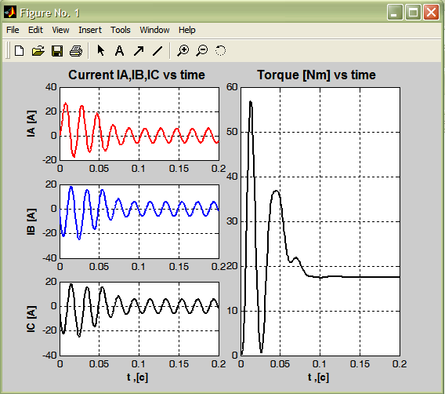 The following figure shows the result of the computer simulation of start up stator current and torque of the 1.7 KW induction motor in the phase coordinate model.

Fig (2.5) Start up stator currents and torque of the 1.7KW of induction motor